**Assignment link:**

**http://eepurl.com/iB3Qic**



Ice cream is a frozen dessert



typically made from milk or



cream that has been flavoured



with a sweetener

ICE CREAM SHOP

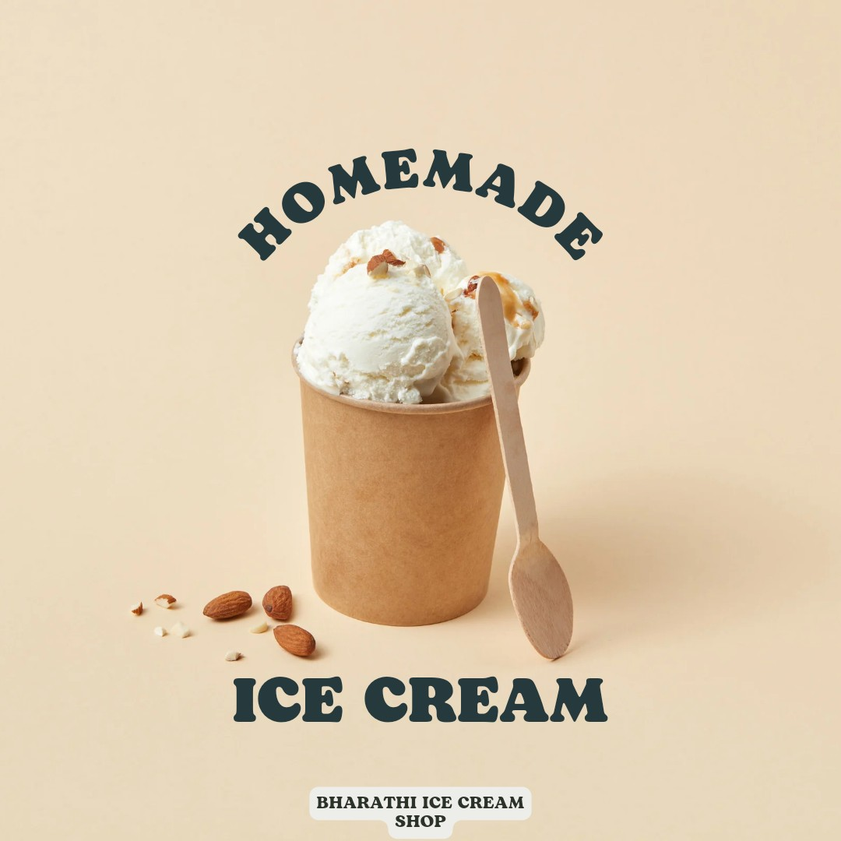

*Copyright (C) 20232023 bharathi icecreams shop. All rights reserved.*

Our mailing address is:

Want to change how you receive these emails? You can [update your preferences](https://coma.us21.list-manage.com/profile?u=4ba062f376cf78751037f1e1e&id=98ae336438&e=%5BUNIQID%5D&c=d8d06baa55) or [unsubscribe](https://coma.us21.list-manage.com/unsubscribe?u=4ba062f376cf78751037f1e1e&id=98ae336438&e=%5BUNIQID%5D&c=d8d06baa55)